**F28SG –INTRODUCTION TO SOFTWARE ENGINEERING**

**CW1 – AN EXERCISE IN DESIGNING A SOFTWARE-BASED SYSTEM**

**INDIVIUAL COURSEWORK**



Devansh Taneja   
 H00460579  
 [dt2041@hw.ac.uk](mailto:dt2041@hw.ac.uk)  
 DUBAI CAMPUS

LINK TO IMAGES:[SG CW IMAGES](https://heriotwatt-my.sharepoint.com/:f:/g/personal/dt2041_hw_ac_uk/EgIZ4H85hg9JpSd4-YvBNz4BHdWSi-IXjccnTRfG9I_FXg?e=IFgHdk)

Contents

TASK 1: ASSUMPTIONS AND EXPECTATIONS 3

1.1. ASSUMPTIONS: 3

1.2. EXPECTATIONS: 3

TASK 2: FUNCTIONAL AND NON-FUNCTIONAL REQUIREMENTS 5

2.1. FUNCTIONAL REQUIREMENT: 5

2.2. NON-FUNCTIONAL REQUIREMENT: 6

TASK 3: USE CASE DIGRAM 7

TASK 4: USE CASE SPECIFICATIONS 8

4.1. BASE USE CASE: Registration 8

4.2. BASE USE CASE: Login 9

4.3. EXTENSION USE CASE: Change Details 10

4.4. BASE USE CASE: Create Rental 10

4.5. BASE USE CASE: Payment 11

4.6. BASE USE CASE: Extend Rental 13

4.7. BASE USE CASE: Return Rental 14

4.8: BASE CASE : Archive Rental 15

TASK 5 : TRACEABILITY MATRIX 16

TASK 6: CLASS DIGRAM 17

TASK 7: SEQUENCE DIGRAM 19

7.1. Main Flow Sequence dig with include use case: payment 19

7.2. Alternative flow 4a of use case: Create Rental 20

7.3. Alternative flow 8a of use case: Create Rental 21

7.4. Alternative flow 2a of Include use case: Payment In Base Use case: Create Rental 22

7.5. Alternative flow 4a of Include use case: Payment In Base Use case: Create Rental 23

7.6. Alternative flow 7a of Include use case: Payment In Base Use case: Create Rental 24

7.7. Alternative flow 10a of Include use case: Payment In Base Use case: Create Rental 25

TASK 8: ACTIVITY DIGRAM 26

8.1. Create Rental 26

8.2. Return Rental 27

8.3. Archive Rental 28

TASK 9: STATE MACHINE DIGRAM 29

TASK 10: SCENARIO TEST CASES 30

# **TASK 1: ASSUMPTIONS AND EXPECTATIONS**

## **1.1. ASSUMPTIONS:**

1. VHS has the capability to recover from unexpected errors or system failures gracefully.
2. Assumption: External services (DVLA, VALIDATEMYCC, RENTALARCHIVE) are assumed to be available in real-time.
3. VHS incorporates necessary security measures to protect sensitive customer data, especially credit card details.
4. VHS includes robust data validation mechanisms to ensure the accuracy and consistency of customer-provided information.
5. Users, including customers and garage technicians, are assumed to receive adequate training on using the VHS system.
6. VHS is designed to handle varying loads of rental requests, vehicle inspections, and data archiving efficiently.
7. VHS maintains an audit trail for all significant transactions and interactions for traceability and accountability.
8. VHS provides multilingual support to accommodate users who may prefer languages other than the default.

## **1.2. EXPECTATIONS:**

1. Users are expected to follow the system prompts and instructions during interactions.
2. The external systems (DVLA, VALIDATEMYCC, RENTALARCHIVE) are expected to meet certain reliability standards.
3. VHS is expected to comply with relevant data protection regulations and industry standards.
4. The touch screen devices used by customers and garage technicians are assumed to be compatible with the VHS interface.
5. Customers are expected to return rental vehicles on time.
6. Users are expected to be aware of and adhere to the rental policies and terms outlined by EASYRENTALS LTD.
7. VHS assumes a secure network connection between different sites and external services to protect data during transmission.
8. External services (DVLA, VALIDATEMYCC, RENTALARCHIVE) are expected to provide timely updates and support for any changes.

# **TASK 2: FUNCTIONAL AND NON-FUNCTIONAL REQUIREMENTS**

## **2.1. FUNCTIONAL REQUIREMENT:**

1. FR1: If the external service VALIDATEMYDVL reject driving License validation, the VHS shall display an error message and abort the process.
2. FR2: The VHS shall store and manage internal records of customer details, including unique ID, name, date of birth, address, mobile number, email, and driving license information.
3. FR3: The VHS shall store credit card details for customers who choose to save them for future rentals, including credit card number, expiry date, and security code.
4. FR4: The VHS shall maintain an internal record of the pool of vehicles available at its associated site, including registration number, current mileage, category, colour, and status.
5. FR5: The VHS shall initiate an inspection process when a customer returns a vehicle, focusing on missing fuel, damages, and mileage.
6. FR6: Daily at 23:59, the VHS shall archive rental records completed within the last 24 hours, sending customer and vehicle details to an external system called RENTALARCHIVE.
7. FR7: Once the transfer to RENTALARCHIVE is successful, the VHS shall delete corresponding internal rental records.
8. FR8: If a selected vehicle category is unavailable, the VHS shall inform the customer and allow them to choose an alternative category.
9. FR9: If customer eligibility check fails during the rental process, the VHS shall display an error message and abort the process.
10. FR10: If the fuel level is below the required amount during the vehicle return process, the VHS shall charge the customer and proceed.
11. FR11: If damages are identified during the vehicle inspection process, the VHS shall record repair charges and proceed with the return process.
12. FR12: If the external service VALIDATEMYCC reject credit card validation, the VHS shall ask customer to enter details again
13. FR13: The VHS shall create and maintain rental records, including references to the customer, the vehicle and start/end dates of rental period

## **2.2. NON-FUNCTIONAL REQUIREMENT:**

1. NFR1: The VHS system shall have a minimum availability of 99.5% during standard operating hours.
2. NFR2: The VHS system shall provide a response time of no more than 5 seconds for customer interactions and validations.
3. NFR3: The VHS system shall implement encryption for storing sensitive customer information, such as credit card details.
4. NFR4: The VHS system shall be designed to handle a minimum of 500 simultaneous rental transactions.
5. NFR5: If an error occurs, the VHS system shall provide clear error messages for customers and technicians.
6. NFR6: The VHS system shall maintain detailed logs of all system activities for auditing and troubleshooting purposes.
7. NFR7: The VHS system should provide a responsive and intuitive user interface to enhance the user experience.
8. NFR8: The VHS system should implement a regular data backup mechanism to prevent data loss in case of system failure.

# **TASK 3: USE CASE DIGRAM**

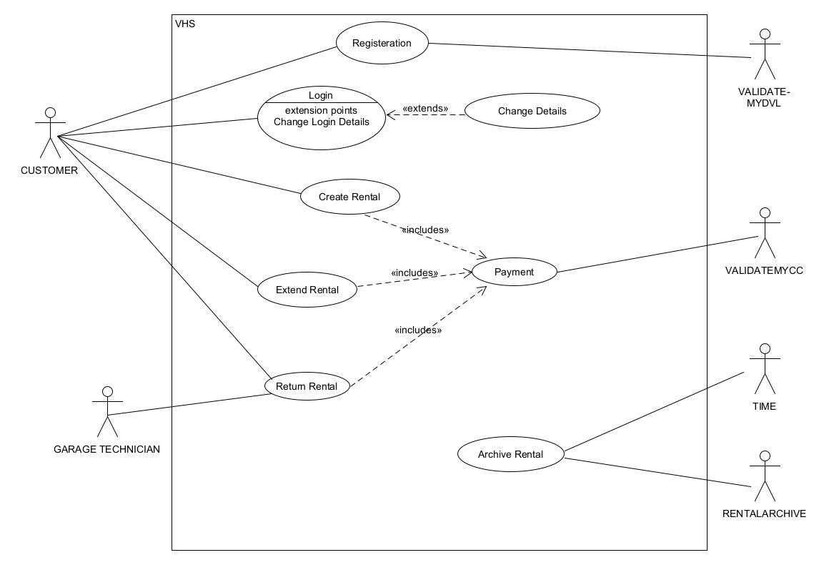

# **TASK 4: USE CASE SPECIFICATIONS**

## **4.1. BASE USE CASE: Registration**

|  |
| --- |
| Use Case: *Registration* |
| ID: *1* |
| Goal: *THE CUSTOMER SUCCESSFULLY REGISTERS* |
| Primary actor: *CUSTOMER* |
| Secondary actor(s): *VALIDATEMYDVL* |
| Preconditions:  *1. THE CUSTOMER IS NOT REGISTERED IN THE SYTEM* |
| Postconditions: *1. CUSTOMER IS REGISTERED IN THE SYSTEM* |
| Main flow:  *1. CUSTOMER ACCESS THE TOUCH SCREEN*  *2. SYSTEM DISPLAYS THE REGISTRATION SCREEN*  *3. CUSTOMER ENTERS PERSONAL DETAILS (NAME, DATE OF BIRTH, ADDRESS, MOBILE NUMBER, EMAIL AND DRIVING LICENSE INFORMATION)*  *4. SYSTEM INTERACTS WITH VALIDATEMYDVL TO VALIDATE DRIVING LICENSE*  *5. VALIDATEMYDVL ACCEPTS DRIVING LICENSE*  *6. SYSTEM ASSIGNS A UNIQUE ID*  *7. CUSTOMER SELECT THE PASSWORD FOR LOGIN*  *8. SYSTEM STORES CUSTOMER’S INFORMATION IN INTERNAL SYSTEM* |
| Alternative flows:  *3a. CUSTOMER FAILS TO PROVIDE NECESSARY DETAILS*  *1. SYSTEM SHOWS AN ERROR MESSAGE*  *2. SYSTEM REQUESTS TO ENTER THE NECESSARY DETAILS*  *3. RETURN TO STEP 3*  *5a. VALIDATEMYDVL REJECTS DRIVING LICENSE*   1. *SYSTEM ACTIVATES AN ERROR MESSAGE* 2. *USE CASE TERMINATES*   *6a. SYSTEM FAILS TO ASSIGN A UNIQUE ID*   1. *SYSTEM ACTIVATES AN ALERT FOR STAFF ASSISTANCE* 2. *USE CASE TERMINATES* |

## **4.2. BASE USE CASE: Login**

|  |
| --- |
| Use Case: *Login* |
| ID: 2 |
| Goal: *THE CUSTOMER SUCCESSFULLY LOGGED IN* |
| Primary actor: *CUSTOMER* |
| Secondary actor(s): *NONE* |
| Preconditions:  *1. THE CUSTOMER IS REGISTERED IN THE SYTEM* |
| Postconditions: *1. CUSTOMER IS LOGGED IN THE SYSTEM* |
| Main flow:  *1. CUSTOMER ACCESS THE TOUCH SCREEN*  *2. SYSTEM DISPLAYS THE LOGIN SCREEN*  *3. CUSTOMER ENTERS UNIQUE ID AND PASSWORD EXTENSION POINT: Change Login Details*  *4. SYSTEM VALIDATES LOGIN DETAILS*  *5. CUSTOMER IS LOGGED IN* |
| Alternative flows:  *4a. SYSTEM FAILS TO VALIDATE LOGIN DETAILS*  *1. SYSTEM REQUESTS TO ENTER THE LOGIN DETAILS AGAIN*  *2. RETURN TO STEP 2*  *5a. SYSTEM FAILS TO LOGIN THE CUSTOMER*   1. *SYSTEM ACTIVATES AN ALERT FOR STAFF ASSISTANCE* 2. *USE CASE TERMINATES* |

## **4.3. EXTENSION USE CASE: Change Details**

|  |
| --- |
| Extension Use Case: Change Details |
| ID: *3* |
| Goal: *CUSTOMER REQUESTS TO CHANGE THE LOGIN DETAILS* |
| Primary actor: *CUSTOMER* |
| Secondary actor(s): NONE |
| Segment Preconditions:  *CUSTOMER IS REGISTERED IN THE SYSTEM* |
| Segment Postconditions: *CUSTOMER LOGIN DETAILS ARE SUCCESSFULLY UPDATED* |
| Segment flow: *Change Login Details*  *1. CUSTOMER REQUESTS TO CHANGE DETAILS*  *2. SYSTEM DISPLAYS THE CHANGE DETAIL SCREEN*  *3. SYSTEM PROMPTS TO PROVIDE VERIFICATION DETAIL (EMAIL OR NUMBER)*  4. CUSTOMER ENTERS VERIFICATION DETAILS  5. SYSTEM VERIFIES THE DETAILS  6. CUSTOMER RECEIVES A RESET LINK  7. CUSTOMER RESETS THE DETAILS  8. SYSTEM PROMPTS TO ENTER NEW DETAILS |

## **4.4. BASE USE CASE: Create Rental**

|  |
| --- |
| Use Case: Create Rental |
| ID: 4 |
| Goal: *THE CUSTOMER SUCCESSFULLY CREATED A RENTAL* |
| Primary actor: *CUSTOMER* |
| Secondary actor(s): *NONE* |
| Preconditions:  *1. THE CUSTOMER IS LOGGED IN THE SYTEM* |
| Postconditions: *1. RENTAL RECORD IS CREATED AND STORED*  *2.VEHICLE SATUS IS UPDATED*  *3. CUSTOMER IS INFORMED ABOUT THE RENTAL DETAILS* |
| Main flow:  *1. CUSTOMER INITIATES THE RENTAL CREATION PROCESS*  *2. SYSTEM PROMPTS TO CHOOSE VEHICLE*  *3. CUSTOMER SELECTS VEHICLE (ECONOMY, PREMIUM, STANDARD OR LARGE)*  *4. SYSTEM CHECKS IF VEHICLE AVAILBLE*  *5. SYSTEM DISPLAY RENTAL FEES AND OTHER CAHRGES*  *6. SYSTEM REQUESTS CUSTOMER TO ENTER RENTAL PERIOD (DATES)*  *7. CUSTOMER ENTERS RENTAL PERIOD*  *8. SYSTEM VALIDATES CUSTOMER’S ELIGIBILITY BASED ON AGE AND CATEGORY OF DRIVING LICENSE*  *9. SYSTEM CALCULATES THE TOTAL COST*  *10. SYSTEM DISPLAYS TOTAL COST*  11. INCLUDE(Payment)  12. UPON SUCCESSFUL VALIDATION AND PAYMENT SYSTEM CONFIRMS THE RENTAL  *13. SYSTEM CREATES A RENTAL RECORD AND UPDATES VEHICLE STATUS TO “UAVAILABLE FOR RENTAL”*  *14. CUSTOMER IS INFORMED ABOUT THE RECORD* |
| Alternative flows:  *4a. VEHICLE IS UNAVAILABLE*   1. *SYSTEM INFORMS THE CUSTOMER*   *2. RETURN TO STEP 2*  *8a. SYSTEM FAILS TO VALIDATE ELIGIBILTY*   1. *SYSTEM ACTIVATES AN ERROR MESSAGE* 2. *USE CASE TERMINATES* |

## **4.5. INCLUDE USE CASE: Payment**

|  |
| --- |
| Use Case: PAYMENT |
| ID: 5 |
| Goal: *AMOUNT IS DEDUCTED FROM THE CARD* |
| Primary actor: *CUSTOMER* |
| Secondary actor(s): *VALIDATEMYCC* |
| Preconditions:  *1. THE TOTAL COST IS CALCULATED* |
| Postconditions: *1. PAYMENT SUCCESSFUL* |
| Main flow:  *1. SYSTEM DISPLAYS TOTAL AMOUND DUE*  *2. SYSTEM PROMPTS CUSTOMER TO USE SAVED CARD OR ADD NEW CARD*  *3. SYSTEM USES SAVED CARD DETAILS*  *4. CUSTOMER CONFIRMS CARD DETAILS*  *5. SYSTEM SENDS CARD TO VALIDATEMYCC*  *6. SYSTEM VALIDATES CARD THROUGH VALIDATEMYCC*  *7. VALIDATEMYCC VALIDATES CARD*  *8. SYSTEM SECURELY PROCESS PAYMENT*  *9. SYSTEM GENERATES RECIPT*  *10. SYSTEM PROMPTS CUSTOMER TO SAVE OR DELELTE CARD*  *11. SYSTEM SECURELY STORES THE CARD DETAILS* |
| Alternative flows:  *2a. CUSTOMER CHOOSES TO ADD A NEW CARD*   1. *SYSTEM PROMPTS CUSTOMER TO ENTER CARD DETAILS* 2. *CUSTOMER ENTERS CARD DETAILS* 3. *RETURN TO STEP 4*   *4a. CUSTOMER DECLINES CARD DETAILS*   1. *SYTEM ASK CUSTOMER TO ENTER NEW CARD DETAILS* 2. *RETURN TO STEP 4*   *7a. VALIDATEMYCC REJECTS CARD*   1. *SYSTEM PROMPTS CUSTOMER TO ENTER CARD DETAILS* 2. *CUSTOMER ENTERS CARD DETAILS* 3. *RETURN TO STEP 4*   *10a. CUSTOMER WANTS TO DELETE CARD*   1. *SYSTEM STORES CARD DETAILS TEMPORARILY* 2. *CARD IS DELETED AFTER THE RENTAL IS RETURNED* 3. *CUSTOMER IS INFORMED ABOUT THIS* |

## **4.6. BASE USE CASE: Extend Rental**

|  |
| --- |
| Use Case: Extend Rental |
| ID: 6 |
| Goal: *RENTAL IS EXTENDED* |
| Primary actor: *CUSTOMER* |
| Secondary actor(s): *NONE* |
| Preconditions:  *1. CUSTOMER HAS ACTIVE RENTAL* |
| Postconditions: *1. RENTAL INSPECTION IS COMPLETE*  *2. CUSTOMER IS INFORMED ABOUT THE RENTAL DETAILS*  *3. VEHICLE SATUS IS UPDATED*  *4. RENTAL RECORD UPDATED* |
| Main flow:  *1. SYSTEM DISPLAYS EXTEND RENTAL SCREEN*  *2. CUSTOMER INTIATES EXTEND RENTAL PROCESS*  *3. SYSTEM PROMPTS CUSTOMER TO CONFIRM EXTEND*  *4. CUSTOMER CONFIRMS*  *5. SYSTEM REQUESTS CUSTOMER TO ENTER RENTAL PERIOD (DATES)*  *6. CUSTOMER ENTERS RENTAL PERIOD*  *7. SYSTEM CHECKS IF VEHICLE AVAILABLE IN THAT PERIOD*  *8. SYSTEM CALCULATES THE TOTAL COST*  9. INCLUDE(Payment)  10. UPON SUCCESSFUL VALIDATION AND PAYMENT SYSTEM CONFIRMS THE RENTAL  *11. SYSTEM UPDATES VEHICLE STATUS TO “UAVAILABLE FOR RENTAL”*  *12. CUSTOMER IS INFORMED ABOUT THE RECORD* |
| Alternative flows:  *4a. CUSTOMER DECLINES*   1. *USE CASE TEMINATES*   *5a. VEHICLE NOT AVAILABLE IN THAT PERIOD*   1. *SYSTEM INFORMS CUSTOMER* 2. *USE CASE TERMINATES* |

## **4.7. BASE USE CASE: Return Rental**

|  |
| --- |
| Use Case: Return Rental |
| ID: 7 |
| Goal: *RENTAL IS RETURNED OR EXTENDED* |
| Primary actor: *CUSTOMER* |
| Secondary actor(s): *GARAGE TECHNICIAN* |
| Preconditions:  *1. CUSTOMER HAS ACTIVE RENTAL* |
| Postconditions: *1. RENTAL INSPECTION IS COMPLETE*  *2. CHARGES FOR MISSING FUEL AND DAMAGES ARE APPLIED*  *3.CUSTOMER IS INFORMED OF INSPECTION RESULT*  *4. RENTAL RECORD UPDATED* |
| Main flow:  *1. SYSTEM DISPLAYS RETURN RENTAL SCREEN*  *2. CUSTOMER INTIATES RETURN RENTAL PROCESS*  *3. SYSTEM PROMPTS CUSTOMER TO CONFIRM RETURN*  *4. CUSTOMER CONFIRMS*  *5. GARAGE TECHINICAIN INSPECTS THE RETURN VEHICLE FOR MISSING FUEL AND DAMAGE*  *6. GARAGE TECHINICAIN INSPECTS NO MISSING FUEL AND DAMAGE AND UPDATES RENTAL RECORD*  *7. GARAGE TECHINICAIN UPDATES SYSTEM*  *8. SYSTEM CALCULATES CHARGES IF ANY*  *9. INCLUDE (Payment)*  10. UPON SUCCESSFUL VALIDATION AND PAYMENT SYSTEM CONFIRMS THE RETURN  *11. SYSTEM UPDATES VEHICLE STATUS TO AVAILABLE* |
| Alternative flows:  *4a. CUSTOMER DECLINES*   1. *USE CASE TEMINATES*   *6a. GARAGE TECHINICAIN FINDS MISSING FUEL AND DAMAGE*   1. *GARAGE TECHINICAIN UPDATES SYSTEM* 2. *SYSTEM CALCULATES THE ADDITIONAL CHARGES* 3. *RETURN TO STEP 9* |

## **4.8: BASE CASE: Archive Rental**

|  |
| --- |
| Use Case: Archive Rental |
| ID: 8 |
| Goal: *RENTAL IS ARCHIVED* |
| Primary actor: *TIME* |
| Secondary actor(s): *RENTALARCHIVE* |
| Preconditions:  *1. DAILY AT 23:59* |
| Postconditions: *1. RENTAL RECORD COMPLETED WITHIN LAST 24 HOURS ARE ARCHIVED*  *2. ARCHIVE RECORDS ARE TRANSFERRED TO RENTALARCHIVE*  *3.CUSTOMER IS INFORMED OF INSPECTION RESULT*  *4. CORRESPONDING INTERNAL RENTAL RECORD DELETED* |
| Main flow:  *1. SYSTEM TRIGGERS ARCHIVING PROCESS AT 23:59*  *2. SYSTEM IDENTIFIES RENTAL RECORD COMPLETED WITHIN LAST 24 HOURS*  *3. SYSTEM SENDS CUSTOMER’S NAME, ADDRESS, VEHICLE REGISTRATION NUMBER AND RENTAL START/END DATE TO RENTALARCHIVE*  *4. RENTALARCHIVE CONFIRMS SUCCESSFUL DATA TRANSFER*  *5. SYTEM DELETES CORRESPONDING INTERNAL RENTAL RECORDS* |
| Alternative flows:  *2a. SYSTEM DOESNOT INDENTIFY RENTAL RECORD*   1. *ARCHIVING PROCESS IS SKIPPED*   *4a. DATA TRANSFER FAILS*   1. *SYSTEM LOGS AN ERROR MESSAGE* 2. *REATTEMPTS THE TRANSFER AT NEXT SCHEDULED ARCHIVING PROCESS* |

# **TASK 5: TRACEABILITY MATRIX**

FUNCTIONAL REQUIREMENT

USE CASE

|  |  |  |  |  |  |  |  |  |
| --- | --- | --- | --- | --- | --- | --- | --- | --- |
|  | UC 1 | UC 2 | UC 3 | UC 4 | UC 5 | UC 6 | UC 7 | UC 8 |
| FR 1 |  |  |  |  |  |  |  |  |
| FR 2 |  |  |  |  |  |  |  |  |
| FR 3 |  |  |  |  |  |  |  |  |
| FR 4 |  |  |  |  |  |  |  |  |
| FR 5 |  |  |  |  |  |  |  |  |
| FR 6 |  |  |  |  |  |  |  |  |
| FR 7 |  |  |  |  |  |  |  |  |
| FR 8 |  |  |  |  |  |  |  |  |
| FR 9 |  |  |  |  |  |  |  |  |
| FR 10 |  |  |  |  |  |  |  |  |
| FR 11 |  |  |  |  |  |  |  |  |
| FR 12 |  |  |  |  |  |  |  |  |
| FR 13 |  |  |  |  |  |  |  |  |

# **TASK 6: CLASS DIGRAM**

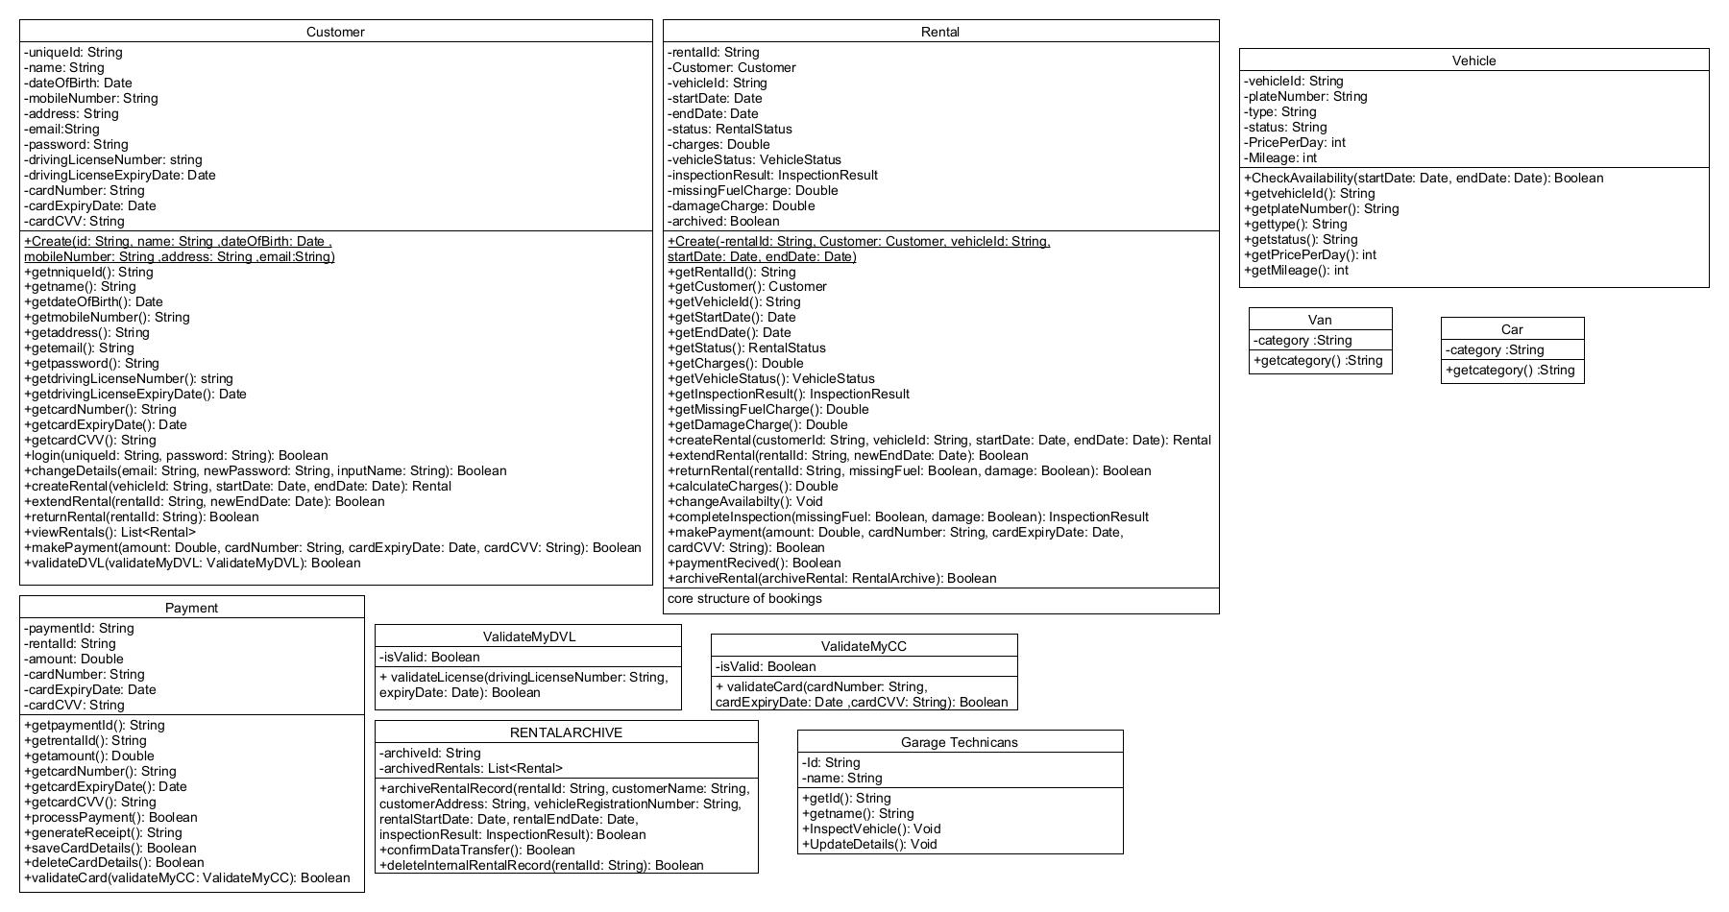**6.1 CLASS DIGRAM DEFINATIONS**

# **TASK 7: SEQUENCE DIGRAM**

## **7.1. Main Flow Sequence dig with include use case: payment**

## **7.2. Alternative flow 4a of use case: Create Rental**

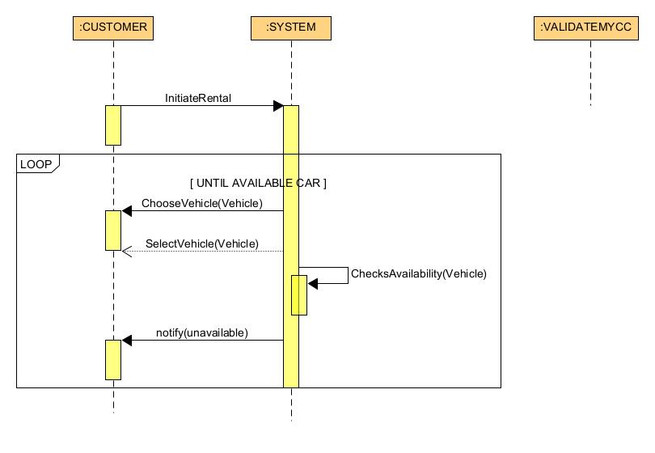

## **7.3. Alternative flow 8a of use case: Create Rental**

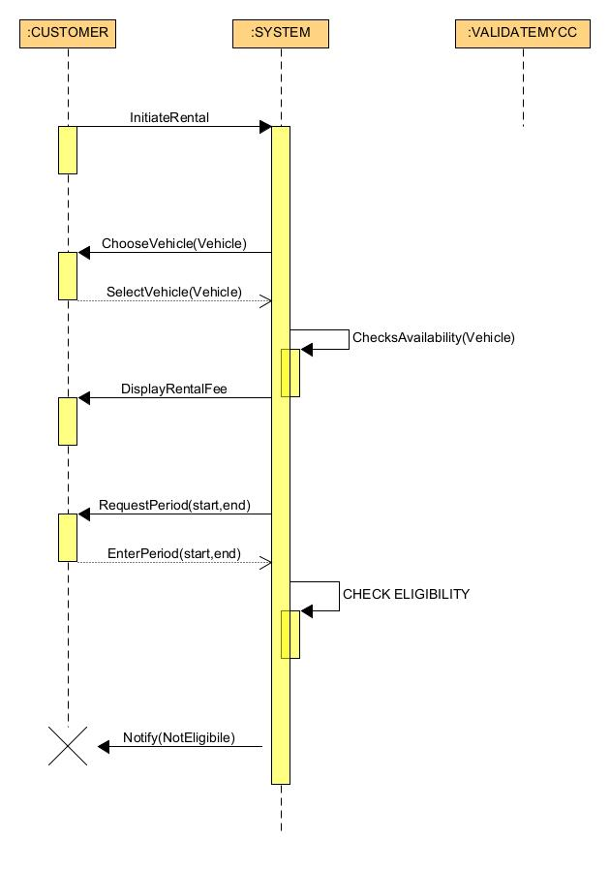

## **7.4. Alternative flow 2a of Include use case: Payment in Base Use case: Create Rental**

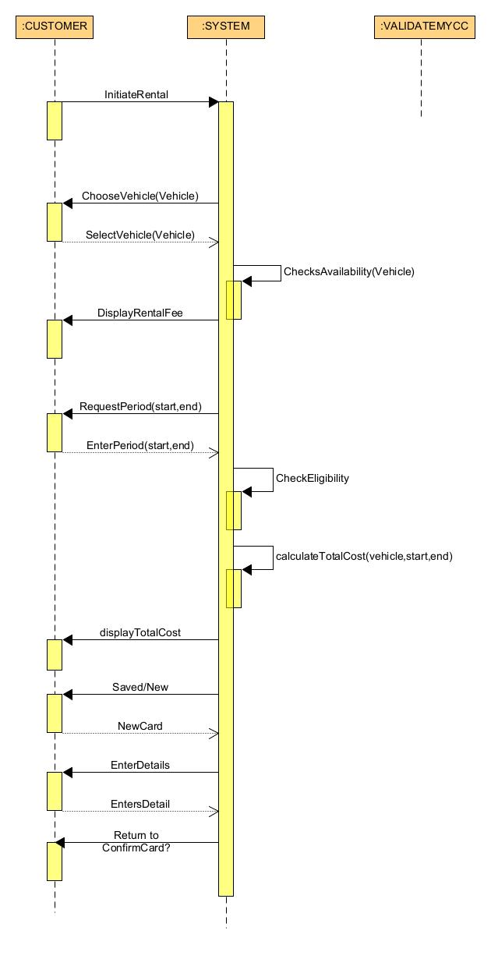

## **7.5. Alternative flow 4a of Include use case: Payment in Base Use case: Create Rental**

## **7.6. Alternative flow 7a of Include use case: Payment in Base Use case: Create Rental**

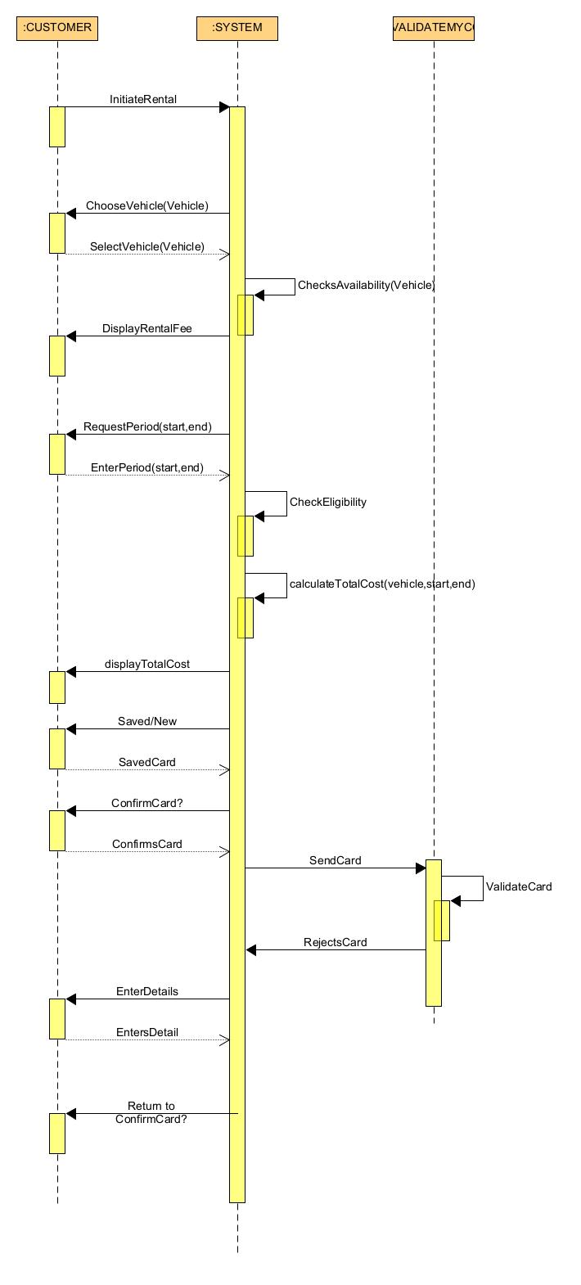

## **7.7. Alternative flow 10a of Include use case: Payment in Base Use case: Create Rental**

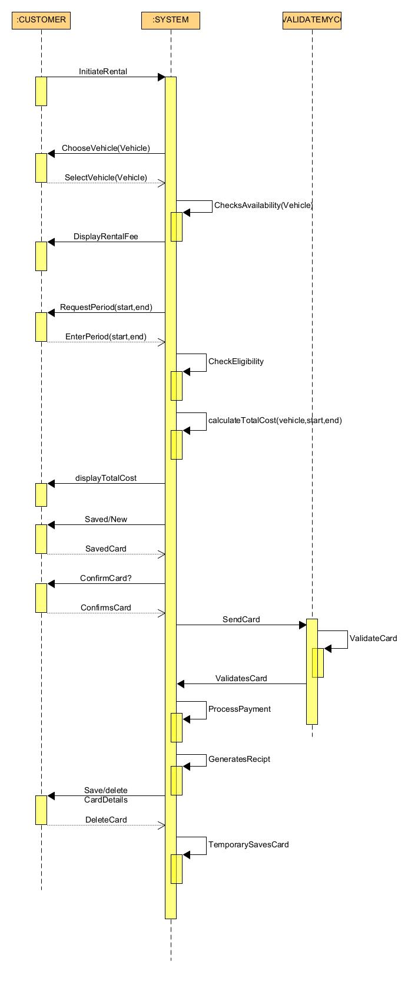

# **TASK 8: ACTIVITY DIGRAM**

## **8.1. Create Rental**

## **8.2. Return Rental**

## **8.3. Archive Rental**

# **TASK 9: STATE MACHINE DIGRAM**

# **TASK 10: SCENARIO TEST CASES**

|  |  |  |
| --- | --- | --- |
| Path | Comment | Path Condition |
| 1 | Successful Rental Creation with Vehicle Available, Customer Eligible, Use Saved card, confirms details, Card validated, Save Card | * Initiate Rental * Send Vehicle Details * Select Vehicle * Check Availability (Available) * Display Rental Fee * Enter rental Period * Validate Eligibility (Eligible) * Calculate Total Cost * Display Total Charges * Use saved or new card (saved) * Confirms Details (confirm) * Send Details to VALIDATEMYCC * Validate card (validates) * Process payment * Generate Receipt * Save or Delete Card (save) * Save Details * Payment Successful * Update Vehicle Status * Inform Customer |
| 2 | Successful Rental Creation with Vehicle Not Available, | * Initiate Rental * Send Vehicle Details * Select Vehicle * Check Availability (Not Available) * Return to step 3: Select Vehicle * Display Rental Fee * Enter rental Period * Validate Eligibility (Eligible) * Calculate Total Cost * Display Total Charges * Use saved or new card (saved) * Confirms Details (confirm) * Send Details to VALIDATEMYCC * Validate card (validates) * Process payment * Generate Receipt * Save or Delete Card (save) * Save Details * Payment Successful * Update Vehicle Status * Inform Customer |
| 3 | Unsuccessful Rental Creation Customer Not Eligible | * Initiate Rental * Send Vehicle Details * Select Vehicle * Check Availability (Available) * Display Rental Fee * Enter rental Period * Validate Eligibility (Not Eligible) |
| 4 | Successful Rental Creation with Use New Card | * Initiate Rental * Send Vehicle Details * Select Vehicle * Check Availability (Available) * Display Rental Fee * Enter rental Period * Validate Eligibility (Eligible) * Calculate Total Cost * Display Total Charges * Use saved or new card (New) * Enter Details * Confirms Details (confirm) * Send Details to VALIDATEMYCC * Validate card (validates) * Process payment * Generate Receipt * Save or Delete Card (save) * Save Details * Payment Successful * Update Vehicle Status * Inform Customer |
| 5 | Successful Rental Creation with Saved Card and Details Declined | * Initiate Rental * Send Vehicle Details * Select Vehicle * Check Availability (Available) * Display Rental Fee * Enter rental Period * Validate Eligibility (Eligible) * Calculate Total Cost * Display Total Charges * Use saved or new card (saved) * Confirms Details (declines) * Enter Details * Return to step 11: Confirm Details * Send Details to VALIDATEMYCC * Validate card (validates) * Process payment * Generate Receipt * Save or Delete Card (save) * Save Details * Payment Successful * Update Vehicle Status * Inform Customer |
| 6 | Successful Rental Creation with Use new Card and Details Declined | * Initiate Rental * Send Vehicle Details * Select Vehicle * Check Availability (Available) * Display Rental Fee * Enter rental Period * Validate Eligibility (Eligible) * Calculate Total Cost * Display Total Charges * Use saved or new card (new) * Enter Details * Confirms Details (declines) * Return To step 11: Enter Details * Send Details to VALIDATEMYCC * Validate card (validates) * Process payment * Generate Receipt * Save or Delete Card (save) * Save Details * Payment Successful * Update Vehicle Status * Inform Customer |
| 7 | Successful Rental Creation with Card Rejected | * Initiate Rental * Send Vehicle Details * Select Vehicle * Check Availability (Available) * Display Rental Fee * Enter rental Period * Validate Eligibility (Eligible) * Calculate Total Cost * Display Total Charges * Use saved or new card * Confirms Details (confirms) * Send Details to VALIDATEMYCC * Validate card (Rejects) * Enter Details * Return to Step 11: Confirms Details Send Details to VALIDATEMYCC * Process payment * Generate Receipt * Save or Delete Card (save) * Save Details * Payment Successful * Update Vehicle Status * Inform Customer |
| 8 | Successful Rental Creation with Delete Card | * Initiate Rental * Send Vehicle Details * Select Vehicle * Check Availability (Available) * Display Rental Fee * Enter rental Period * Validate Eligibility (Eligible) * Calculate Total Cost * Display Total Charges * Use saved or new card (saved) * Confirms Details (confirm) * Send Details to VALIDATEMYCC * Validate card (validates) * Process payment * Generate Receipt * Save or Delete Card (Delete) * Temporary Save Details * Payment Successful * Update Vehicle Status * Inform Customer |